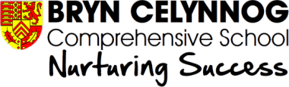

School Uniform Orders for Click & Collect

Student: …………..………………………………………………………………………….…… Year: ..…………

Parent/Guardian: …………………………………………………………………..………………………..…..…..

Contact Details:
Mobile ………………………………………… Email ………………………………………………………..………………

Basic Uniform | Size | Qty
Blue Polo Shirt – BOYS / GIRLS (Pls delete as required)
Black Sweat Shirt
Black Jumper BOYS / GIRLS (Pls delete as required)
Cardigan
Skirt
Trousers – Boys
Trousers – Girls
Black Fleece Jacket
PE:
Sky Blue Sweatshirt
Gym Skort
Navy Leggings
White Polo Shirt
Games Socks BOYS / GIRLS (Pls delete as required)
Rugby Shirt
Black Shorts

To obtain your garments, please fill in the order form and return it via email to julie.grant@bryncelynnog.org.uk.

